Where we live (Şırnak-Turkey)

Sirnak is a small city in eastern Turkey. Sirnak; Guti was a settlement connected to Cizre during the Babylonian, Med, Assyrian, Persian, Sassanid, Umayyad, Abbasid, Seljuk and Ottoman periods. It became a district in 1914 and was connected to Siirt and Şırnak became a province in 1990.

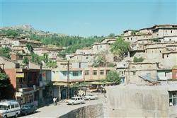

Since the Flood event, which has a history of 19800 years, ended on the Cudi Mountain, located within the borders of Şırnak province, Şırnak and Cizre became the second cradle of all people of the world. Hz. The fact that the tomb of the Prophet Noah is in Cizre, the walls of Cizre are in the shape of a ship, the Gut, Babylon, Assyrian inscriptions and reliefs prove this. In addition, the almighty Qur'an writes that the Ark of the Flood-Noah stopped on Mount Judi.

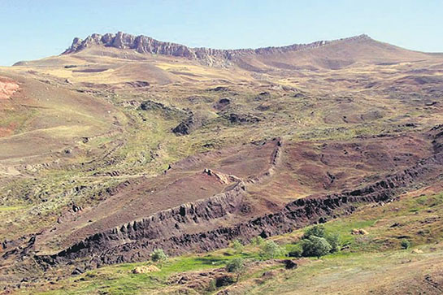

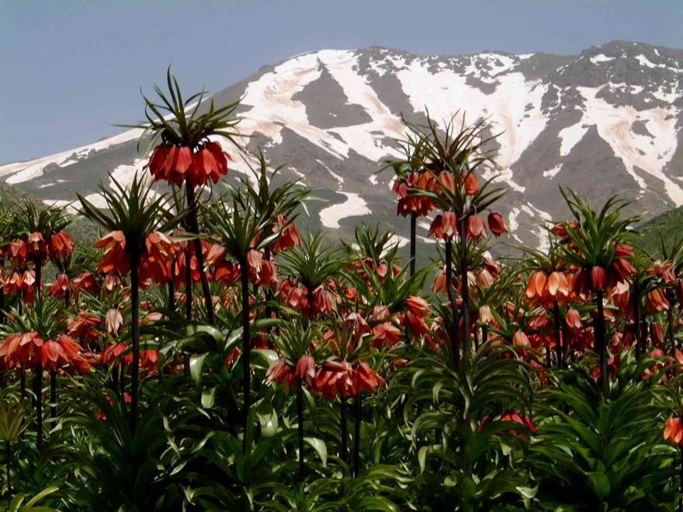
Inverted tulip is an endemic flower species belonging to Anatolian geography. According to the Inverted Tulip Christian legends; Witnessing the crucifixion of Jesus Christ. Inverted Tulip started to grow where Meryem's tears fell. According to Muslim legends; Hz. Due to the murder of Hasan and Hüseyin in Karbala and, according to another legend, a couple in love named Ferhat and Şirin could not reunite with each other, the neck of Reverse Lale is bent and its color is red.

The Mor Dodo Church in the city is a historical church where Assyrians worship.

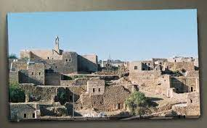

The ruins dating back to 4000 BC are in Cizre. It is located opposite Düzova and İdil Hendek villages, on the banks of the Tigris River in Güçlükonak district. Relief sculptures of Assyrian and Gutians are found here. Water cisterns, houses carved out of rocks, pictures of women, and secret water stairs are among the most important works.

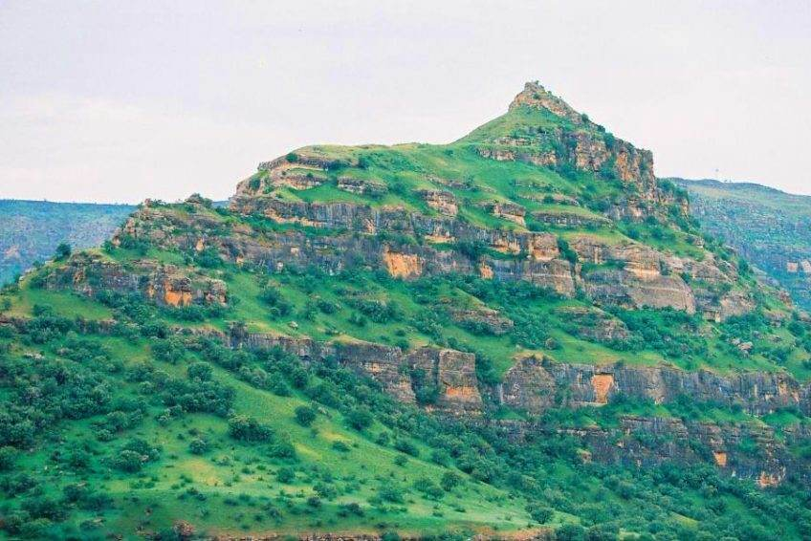

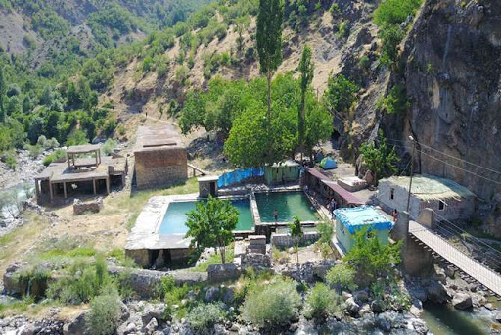
It is known that the hot spring water with a water temperature of 39 degrees is good for rheumatism and skin diseases. In fact, since it is known to be good for many ailments apart from these diseases, it welcomes many visitors from the surrounding provinces.

Şırnak is a small city with limited opportunities. It has lagged behind in terms of development. It fascinates people with its history and magnificent geography.
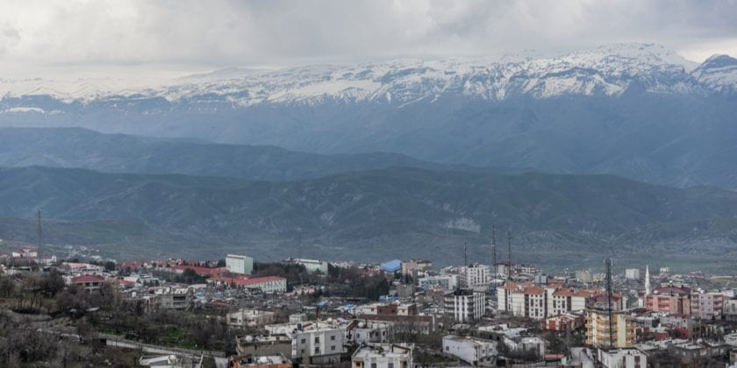

Thank you dear readers

